https://www.jianshu.com/p/fd34fa2ddcd9

public void onClick(View view) {

TelephonyManager tm = (TelephonyManager) this.getSystemService(Context.TELEPHONY_SERVICE);

//手机上存在两个imei值，分配给两个卡槽
Log.d("Q_M", "imei：" + tm.getImei());
Log.d("Q_M", "imei0：" + tm.getImei(0));
Log.d("Q_M", "imei1：" + tm.getImei(1));

//手机上只会存在一个meid,两个卡槽获取的一样
Log.d("Q_M", "meid：" + tm.getMeid());
Log.d("Q_M", "meid0：" + tm.getMeid(0));
Log.d("Q_M", "meid1：" + tm.getMeid(1));
}

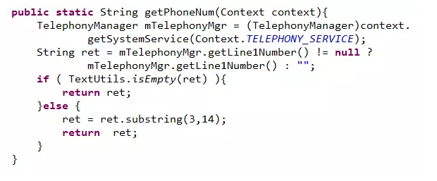

https://blog.csdn.net/xxf377376701/article/details/77054102
https://www.cnblogs.com/android100/p/android-get-num.html

----短信
https://www.cnblogs.com/android100/p/android-get-num.html

